RAIGAD FORT
Raigad, located in the Raigad district of Maharashtra, India, is a hill fort situated near the town of Mahad. It is one of the strongest fortresses on the Deccan Plateau and was historically referred to as Rairee or Rairy Fort. Raigad is the largest fort in Asia, with an area of 1,200 acres.Chhatrapati Shivaji Maharaj, the Maratha ruler, along with his chief engineer Hiroji Indulkar, oversaw the construction and development of various buildings and structures at the fort. In 1674, following his coronation as king, Shivaji chose Raigad as the capital of his Hindavi Swaraj.
Located at an elevation of 820 metres (2,700 ft)above sea level in the Sahyadri mountain range, the fort offers panoramic views of the surrounding region. The fort was home to around 1,550 residents, with an average family size of five. Access to the fort requires ascending approximately 1,737 steps. Alternatively, visitors can use the Raigad Ropeway, an aerial tramway spanning 750 m (2,460 ft) in length and reaching a height of 400 m (1,300 ft), which transports passengers to the fort in approximately four minutes.
Major features
The main palace was constructed of wood, of which only the base pillars remain. The fort ruins include the queen's quarters, and six chambers, each with a private restroom. The chambers lack windows. In front of the palace grounds are the remains of three watchtowers, of which only two survive, as the third was destroyed during a bombardment. The fort also overlooks an artificial lake known as Ganga Sagar Lake.
The primary access route to the fort passes through the “Maha Darwaja” (Great Gate), which was traditionally closed at sunset. The Maha Darwaja is flanked by two bastions, each approximately 20–21 m (65–70 ft) high. The top of the fort rises 180 m (600 ft) above this entrance.
The king's court within Raigad Fort contains a replica of the original throne, which faces the main doorway called the Nagarkhana Darwaja. The throne is oriented towards the east. It was here that Chhatrapati Shivaji Maharaj was crowned. The enclosure was acoustically designed to allow sound to travel from the doorway to the throne.
A secondary entrance, called the Mena Darwaja on the southern side, is believed to have been the private entrance for the royal women and leads to the queen’s quarters. The Palkhi Darwaja on the northern side was used by the king and his entourage. To the right of the Palkhi Darwaja is a row of three deep, dark chambers, which historians believe served as granaries.
The fort overlooks Takmak Tok, a cliff used as an execution site from which condemned prisoners were thrown to their deaths. This area is now fenced off.
A statue of Shivaji is erected in front of the ruins of the main market avenue that leads to the Jagdishwar Mandir, which has Sardar Hiroji Indulkar's name engraved on the first step, his own Samadhi and that of his dog named Waghya. The Samadhi of Rajmata Jijabai, Shivaji's mother, can be seen at the base village of Pachad. Additional attractions of the fort include the Khubladha Buruj, Nane Darwaja and the Hatti Talav (Elephant Lake). Henry Oxienden was on the fort from 13 May to 13 June 1674 & he quoted "We arrived at the top of that strong mountain about sun set, which is fortified by nature more than art, being off very difficult access, and but one advance to it, which is guarded by two narrow gates, and fortified with a strong high wall, and bastions thereto. All the other parte of the mountaine is a direct precipice, so that it is impregnable except the treachery of some in it betrays it. On the Mountain are many strong buildings, as the Raja's Court, and houses for other Ministers of State, to the number of about 300, It is in length about 21 miles and breadth * a mile, but no pleasant trees nor any sort of grains grows thereon. Our house was about a mile from the Raja's Palace, into which we retired with no little content."
Hirakani Buruj
The fort has a historic buruj called "Hirakani Buruj" (Hirakani Bastion) constructed over a huge steep cliff. The legend goes "that a milkmaid named as Hirakani from a nearby village had come to sell milk to the people living at the fort. She happened to be inside the fort when the gates got closed and locked at sunset. Hearing the cries of her infant son back at the village echo after nightfall, the anxious mother couldn't wait till dawn and courageously climbed down the steep cliff in pitch darkness all for the love of her little one. She later repeated this extraordinary feat in front of Shivaji and was rewarded for her bravery." Noticing that this was a potential loophole, Shivaji built a bastion over the cliff and named it after the milkmaid as Hirakani Buruj.
Raigad Ropeway
The "Raigad Ropeway" is a ropeway which provides passenger transportation to the fort. Prior to the ropeway the only way to ascend Raigad fort was to trek to it, which took an hour. The Ropeway makes this site relatively more accessible to those not in a physical condition to make this trek. The Raigad Ropeway project is a non-profit endeavour, being the only one of its kind in India. This facility is owned by the Shri Shivaji Raigad Smarak Mandal, (SSRSM) Pune, an organisation started by Bal Gangadhar Tilak in 1886.Contruction of this Ropeway was completed in 1996.
In 1990, the SSRSM was permitted by the government of Maharashtra to construct the ropeway. An offer of Rupees Eighty Million, received from a Central Government firm, from Naini, Allahabad, was considered to be unviable. Subsequently, Jog Engineering Limited offered to execute the project on a Build–operate–transfer basis in 1994, at a cost of INR 31 Million, and the same was accepted by SSRSM.
The construction work commenced in November 1994, and was completed by March 1996. The project was inaugurated by Prof. Rajendra Singh, Sarsanghchalak of the Rashtriya Swayamsevak Sangh. The ascent is 420 m and the rope length is 760 m. The motor capacity is 52.22 kW and the cabin weight is 100 kg each.
Raigad Fort is one of the most important historical forts in Maharashtra and occupies a special place in the history of the Maratha Empire. It is situated in the Sahyadri mountain range in present-day Raigad district of Maharashtra. The fort is closely associated with Chhatrapati Shivaji Maharaj because it served as the capital of his kingdom and witnessed his coronation in 1674. Raigad was not simply a military fort; it was a carefully planned centre of administration, politics, trade, religion and royal life. The fort's location on a high mountain provided natural protection and allowed its defenders to observe the surrounding region. Even today, Raigad remains an important symbol of Maratha history and the idea of Swarajya.
Reasons for the Destruction of Raigad Fort
The destruction of Raigad Fort was not caused by a single event. The fort gradually suffered damage because of military conflicts, deliberate destruction, neglect and natural weathering over several centuries. Its location on a high mountain exposed its structures to heavy monsoon rainfall, strong winds and vegetation growth, while later political conflicts caused additional damage.

1. Mughal attack and capture:One of the major periods of destruction occurred during the conflict between the Marathas and the Mughal Empire. After Shivaji Maharaj's death in 1680, the Mughal-Maratha conflict intensified. In 1689, Mughal forces captured Raigad. During this period of military occupation and conflict, several structures of the fort were damaged. The change in control also affected the maintenance of the buildings and defensive structures.

2. Military conflicts:Raigad was a strategically important fort, so it became involved in repeated political and military struggles. Battles and military activity could damage walls, gateways, buildings and other structures. Defensive structures were particularly vulnerable during attacks because they were directly involved in warfare. The fort subsequently changed hands, and its condition deteriorated over time.

3. British attack and destruction:A major phase of damage occurred during the Third Anglo-Maratha War. In 1818, British forces captured Raigad. During the military operations, parts of the fort were damaged, and several buildings were subsequently left in ruins. This period is important when discussing the physical destruction visible at Raigad today.It is worth noting that not every ruined structure at Raigad was destroyed in a single British attack. Some buildings had already deteriorated because of earlier conflicts and lack of maintenance.

4. Abandonment and neglect:After the decline of Raigad's political and military importance, the fort was no longer maintained as an active capital or major administrative centre. Once a large permanent population and military presence disappeared, many buildings were left unused.Without regular maintenance, walls weakened, roofs collapsed and pathways deteriorated. Over a long period, neglect probably caused as much deterioration as warfare.

5. Heavy monsoon rainfall:Raigad is located in the Konkan region, which receives heavy southwest monsoon rainfall. Continuous exposure to rain causes weathering of stone and mortar. Water enters cracks and joints, weakens structures and accelerates erosion.The combination of heavy rainfall and steep slopes also causes soil erosion around some parts of the fort. This makes long-term preservation particularly challenging.

6. Strong winds and weathering:Because Raigad is situated at a high elevation, the fort is exposed to strong winds and changing weather conditions. Continuous exposure to wind, rain, humidity and temperature changes gradually damages exposed stone surfaces and masonry.This process is called natural weathering, and it occurs slowly over many years.

Losses Due to the Destruction of Raigad Fort:The destruction and deterioration of Raigad Fort resulted in the loss of many important historical, architectural and cultural features. The damage was not limited to the physical buildings; it also resulted in the loss of information about the daily life, administration and engineering practices of the period. Because many structures are now in ruins, historians have to depend on archaeological remains, historical records and other evidence to reconstruct what Raigad was like when it functioned as a capital.

1. Loss of Historical Structures:One of the biggest losses is the destruction of many original buildings. Raigad once contained royal residences, administrative buildings, residential areas, storage facilities and other structures. Many of these buildings no longer survive in their original form. As a result, it is difficult to understand the complete layout and appearance of the former capital.

2. Loss of Architectural Heritage:The fort originally contained numerous examples of Maratha-period architecture and construction techniques. The destruction of buildings, walls and other structures has reduced the amount of original architecture available for study. This represents a significant loss for historians, archaeologists, architects and students interested in traditional construction.

3. Loss of Historical Information:Buildings themselves provide valuable information about the people who constructed and used them. When a structure disappears, information about its original purpose, design and construction may also be lost. For example, the ruins of residential and administrative buildings provide only partial evidence about how people lived and worked at Raigad.

4. Loss of Royal and Administrative Heritage:Raigad functioned as a major political and administrative centre. The destruction of administrative buildings means that much of the physical evidence of how the capital operated has disappeared. Although historical documents provide information about administration, the original buildings could have provided additional evidence about the organization of the kingdom.

5. Loss of Cultural Heritage:Raigad was an important centre of cultural and religious activities. The deterioration of temples, residences and other cultural structures represents a loss of tangible heritage. These structures helped connect present generations with the cultural environment of the historical period.

6. Loss of Archaeological Evidence:Every historical structure contains archaeological information. Stones, foundations, floor plans, drainage systems, storage areas and construction materials can help researchers understand the past. When structures collapse or are removed, some of this evidence becomes difficult or impossible to recover.

7. Loss of Traditional Engineering Knowledge:Raigad contained sophisticated systems for water storage, drainage, transportation and defence. Damage to these structures means that some knowledge of historical engineering techniques has been lost. The surviving structures are therefore extremely valuable because they allow researchers to study how people adapted engineering practices to the difficult mountain environment.

Chronological Timeline of Raigad Fort
- Pre-1656 (Early History & Riri Hill):
  - The site was originally a modest hill known as Riri, lacking any major fortification before being developed into a capital.
- May 15, 1656 (Acquisition and Development):
  - Chhatrapati Shivaji Maharaj captured the fort from Chandra Rao More. Over the next 14 years, he transformed it into a massive capital equipped with hundreds of structures, lakes, and water cisterns.
- June 6, 1674 (The Golden Era):
  - Shivaji Maharaj's historic coronation took place at Raigad, establishing it as the political heart of the Maratha Empire.
- 1680 (Death of Shivaji Maharaj):
  - Following the king's death on the fort, the intense Mughal-Maratha conflict began to escalate, initiating the gradual decline and vulnerability of the capital.
- 1689 (Mughal Capture & Initial Damage):
  - Mughal forces successfully captured Raigad. This period of military occupation, conflict, and shifting control resulted in structural damage and the first major lapse in regular maintenance.
- Post-Mughal Era to Early 19th Century (Abandonment & Decay):
  - As political power shifted, the fort lost its status as an active, bustling capital. The departure of the permanent population and military presence led to prolonged abandonment and neglect. Without upkeep, walls weakened and roofs collapsed, while heavy monsoon rains, strong winds, and natural weathering continuously eroded the stone and mortar masonry.
- 1818 (British Attack & Third Anglo-Maratha War):
  - British forces attacked and captured Raigad. Artillery fire and military operations during this campaign left many remaining buildings in ruins, contributing significantly to the visible physical destruction seen today.
- Post-1818 to Modern Era (Ongoing Natural Decay & Preservation):
  - Decades of continuous exposure to the Konkan region's harsh monsoons, steep-slope soil erosion, and wind weathering further deteriorated the abandoned ruins, prompting later efforts by archaeological bodies to restore and preserve the surviving structures.

Original Name of Raigad
Before it became known as Raigad, the fort was called Rairi or Rairy. It existed as an important hill fort before Shivaji Maharaj took control of it. Historical sources mention several names associated with the fort during different periods. Shivaji Maharaj recognized the strategic importance of Rairi and captured it in 1656. After taking control of the fort, he began developing and strengthening it. The transformation of Rairi into Raigad was significant because the fort was gradually converted from an existing hill stronghold into the capital of an expanding kingdom. The new development included royal buildings, administrative structures, marketplaces, temples, water-storage facilities and stronger defensive arrangements.

Capture by Shivaji Maharaj
Shivaji Maharaj captured Rairi in 1656. This event was an important stage in the development of the Maratha kingdom. Shivaji Maharaj had already begun establishing his authority over different forts and territories, and Rairi offered several advantages because of its geographical position and natural strength. After capturing it, he understood that the fort could be developed into a secure centre of government. Construction and improvement work was therefore carried out on a large scale. The fort was strengthened with walls, gateways, bastions, buildings, roads, water systems and other facilities. Over time, Rairi became Raigad and developed into one of the most important centres of the Maratha state.

Raigad as the Capital
Raigad became the capital of Shivaji Maharaj's kingdom and was developed as a complete administrative and royal centre. The decision to make Raigad the capital was based on its strong geographical and military position as well as its ability to accommodate a permanent settlement. The fort contained areas for the royal family, government officials, soldiers, traders and other residents. There were also places for religious activities, storage of water and food, and conducting administrative work. The presence of a marketplace shows that Raigad was not only a military installation but also a functioning settlement. Its development demonstrates the organizational capabilities of the Maratha administration during Shivaji Maharaj's reign.

Importance of the Coronation
The most famous event in the history of Raigad was the coronation of Chhatrapati Shivaji Maharaj on 6 June 1674. The coronation was an important political and cultural event because Shivaji Maharaj formally assumed the title of Chhatrapati. It represented the establishment of an independent Maratha sovereignty and gave formal recognition to the kingdom that had been built through years of military, political and administrative efforts. Leaders, officials, scholars and representatives participated in the ceremony. The coronation gave Raigad an even greater position in Indian history because it became the seat from which Shivaji Maharaj ruled as a sovereign king. The event is closely associated with the concept of Swarajya, or self-rule, which formed an important part of Shivaji Maharaj's political vision.

Raj Darbar
The Raj Darbar was one of the most important areas of Raigad Fort. It served as the royal court where official matters were conducted and important visitors could meet the king. The remains of the Raj Darbar provide evidence of the administrative character of the fort. The area was designed to accommodate royal proceedings and demonstrates that Raigad functioned as the political centre of the Maratha kingdom. The large open space associated with the court would have been useful for gatherings and official activities. Today, the Raj Darbar is one of the major historical attractions of Raigad and helps visitors understand the importance of the fort as a capital rather than merely a defensive structure.

Maha Darwaja
The Maha Darwaja, meaning the Great Gateway, was an important entrance to Raigad Fort. Gateways played an important role in the defensive architecture of hill forts. They were designed to control access and make it difficult for an enemy to enter the fort. The location and construction of the gateways at Raigad demonstrate how the natural landscape was combined with human engineering. An attacking army approaching the fort would have faced steep terrain and strong defensive positions. The Maha Darwaja therefore had both practical and symbolic importance. It represented the controlled entrance to the capital of the Maratha kingdom and remains one of the most recognizable structures of Raigad.

Takmak Tok
Takmak Tok is one of the most well-known locations at Raigad Fort. It is situated at a dramatic edge of the mountain and provides extensive views of the surrounding valleys and landscape. The location is particularly famous because of historical stories connected with punishments during the period of the Maratha kingdom. However, today Takmak Tok is mainly visited as a historical viewpoint and as one of the important attractions of Raigad. Standing at this location gives visitors an understanding of the natural defensive advantages of the fort. The steep cliffs surrounding the fort made it extremely difficult for an attacking army to approach from many directions.

Queen's Palace
The Queen's Palace, commonly referred to as Rani Vasa, was an important residential section of Raigad. It was associated with the royal women of the Maratha court. The remains of the palace provide information about the residential organization of the fort. The existence of a separate royal residential area demonstrates that Raigad was designed as a permanent capital where the royal family could live safely. Along with the palace, other buildings were constructed to support royal life and administration. Although only ruins remain today, they provide valuable evidence about the scale and organization of the former capital.

Jagadishwar Temple
The Jagadishwar Temple is another important structure at Raigad Fort. The temple is dedicated to Lord Shiva and reflects the religious and cultural character of the Maratha capital. Religious institutions were an important part of society during this period, and the presence of the temple within the fort demonstrates that Raigad was designed to support not only political and military activities but also the spiritual life of its residents. The temple continues to be an important place for visitors and forms an important part of the historical landscape of Raigad.

Shivaji Maharaj's Samadhi
Raigad is also the place where Chhatrapati Shivaji Maharaj's samadhi is located. Shivaji Maharaj died at Raigad in 1680, only a few years after his coronation. His samadhi has become an important place of remembrance and respect. Thousands of people visit Raigad to pay tribute to him and learn about his contribution to the history of Maharashtra. The presence of the samadhi makes Raigad important not only as the place where Shivaji Maharaj established his capital and was crowned but also as the place associated with the final period of his life. It has therefore become a powerful symbol of his historical legacy.

Market Area
The market area of Raigad provides evidence that the fort was a well-organized settlement. A capital with a large population required regular supplies of food, clothing, tools and other materials. The marketplace would have served residents, soldiers, officials and visitors. The arrangement of the market demonstrates that economic activities were an important part of life at Raigad. The existence of such a marketplace also helps historians understand the scale of the settlement. Raigad was therefore not an isolated military structure; it was a living centre containing different sections for political, social, economic and religious activities.

Water Management
Water management was extremely important for the survival of any hill fort. Since Raigad was situated on a mountain, the people living there needed reliable sources of water throughout the year. Various tanks, reservoirs and water-storage systems were developed to meet this requirement. Ganga Sagar is one of the important water bodies associated with Raigad. These structures demonstrate the engineering skills used by the builders of the fort. A well-designed water system allowed the fort to support a large population and remain capable of resisting a prolonged siege. The water-management system is therefore an important example of the practical planning used in the construction of Raigad.

Architecture of Raigad
The architecture of Raigad reflects the defensive requirements of a hill fort as well as the needs of a royal capital. The fort contains stone walls, gateways, bastions, stairways, temples, residential buildings, royal structures, marketplaces and water-storage facilities. One of the most interesting features is the way the builders used the existing mountain landscape. Instead of depending entirely on artificial walls, the natural cliffs and steep slopes themselves became part of the defensive system. The combination of natural and artificial defence made the fort difficult to attack. The architecture therefore demonstrates both military planning and civil engineering knowledge.

Military Importance
Raigad was extremely important from a military point of view. Its elevated position provided defenders with an advantage because they could observe approaching forces from a distance. The steep slopes made it difficult for large armies to reach the upper areas of the fort. Strong gateways and walls further increased its defensive strength. The fort could also store supplies and accommodate soldiers, allowing it to function as a secure military base. Its location between the Deccan and Konkan regions also increased its strategic importance. Raigad therefore served both as the political capital and as a major defensive centre of the Maratha kingdom.

Administrative Importance
Raigad was the centre of administration during the period when it served as the capital of Shivaji Maharaj's kingdom. Important decisions relating to the kingdom were taken from the capital. Government officials dealt with matters such as taxation, justice, military organization, diplomacy, trade and communication. The development of separate administrative and royal areas shows that the Maratha state had an organized system of governance. Raigad therefore provides important evidence that the Maratha kingdom was not based only on military expansion but also on administrative organization and state-building.

Raigad After Shivaji Maharaj
After the death of Shivaji Maharaj in 1680, Raigad continued to play a role in the political struggles of the Maratha period. The political situation became increasingly complicated because of conflicts between the Marathas and the Mughal Empire. In 1689, the fort came under Mughal control. It was later recovered by the Marathas in 1733 during the period of Shahu Maharaj. These changes demonstrate the continuing strategic importance of Raigad even after Shivaji Maharaj's death.

Raigad During British Rule
The political power of the Marathas eventually declined, and British power expanded across large parts of India. Raigad eventually came under British control. The fort's political importance decreased, but its historical importance continued. The surrounding region was known as Kolaba district during the British period. In 1869, Kolaba was established as a separate district, and the district was later renamed Raigad. The modern name of the district therefore preserves the memory of the historic fort and its importance in Maharashtra's history.

Raigad as a Symbol of Swarajya
Raigad has become one of the strongest symbols associated with the idea of Swarajya. For Shivaji Maharaj, Swarajya represented self-rule and the establishment of an independent political authority. The coronation at Raigad in 1674 gave formal expression to this political idea. The fort therefore represents more than military victory. It represents the establishment of a functioning kingdom with its own administration, military organization, economic system and royal authority. This symbolic importance is one of the reasons why Raigad continues to hold a special place in the cultural memory of Maharashtra.

Tourism and Present-Day Importance
Today, Raigad Fort is an important historical and tourist destination in Maharashtra. People visit the fort for trekking, sightseeing, photography, historical study and educational purposes. Visitors can reach the fort by climbing approximately 1,737 steps or by using the Raigad Ropeway. The ropeway provides an easier way to reach the top of the fort and has made the site more accessible to visitors. Important attractions include the Maha Darwaja, Raj Darbar, Takmak Tok, Jagadishwar Temple, Queen's Palace, marketplace, water structures and Shivaji Maharaj's samadhi.

Educational Importance
Raigad is valuable as an educational site because it allows students to study several subjects together. From a historical perspective, it provides information about Shivaji Maharaj and the Maratha Empire. From a geographical perspective, it demonstrates how mountains and natural landscapes can influence human settlement and defence. From an architectural perspective, the fort provides examples of historical construction techniques. From an engineering perspective, its water-storage systems, roads, stairways and defensive structures are particularly interesting. Raigad can therefore be considered a kind of open-air classroom where history, geography, architecture and engineering can be studied together.
UNESCO World Heritage Status (2025)
Raigad has recently received major international recognition. It's now part of the "Maratha Military Landscapes," a group of 12 forts linked to Chhatrapati Shivaji Maharaj that were formally declared a UNESCO World Heritage Site, marking India's 44th World Heritage Site. The other forts in this group include Shivneri, Pratapgad, Sindhudurg, Suvarnadurg, Lohgad, Rajgad, Panhala, Vijaydurg, Khanderi, Salher, and Gingee Fort in Tamil Nadu. This inscription was formally confirmed at the 47th session of the World Heritage Committee in 2025, under criteria iv and vi for cultural significance. The nomination effort itself involved a Maharashtra government delegation traveling to Paris in February 2025 to present the state's case for recognition to UNESCO.
Nickname and Ownership History
Raigad is sometimes called the "Gibraltar of the East" because of its highly strategic, naturally fortified location. Ownership of the fort passed through several hands over the centuries — from the Chandrarao More family before 1656, to the Maratha Empire, briefly to the Mughal Empire, then to the East India Company from 1818, and finally to the Government of India after independence in 1947.
Key Historical Events at the Fort
Beyond Shivaji's own coronation, Raigad witnessed the coronations of his successors as well: Sambhaji was crowned there on 16 January 1681, and Rajaram on 11 March 1689.
Modern Redevelopment Project
The fort is currently undergoing a large-scale revamp aimed at boosting international tourism. Sambhajiraje Chhatrapati, a descendant of Shivaji Maharaj and a Rajya Sabha member, is chairing the Raigad Development Authority overseeing this work. Funding details include: of Rs 606.08 crore sanctioned for the Authority, Rs 114 crore has been earmarked specifically for the fort itself, while nearly Rs 237 crore has been sanctioned for road works connecting Mahad to Raigad Fort, which is being developed as a "heritage highway." Separately, around Rs 100 crore is expected from the central government for the revamp of ten forts, based on recommendations from the 15th Finance Commission. The fort currently falls under the jurisdiction of the Archaeological Survey of India (ASI).
A Related but Distinct Fort
Note that there's a separate, smaller ruin also carrying "Raigad" in its name — Manikgad, located in Raigad district near Rasayani. It's unrelated to the main hill fort discussed in your document: it was built around 1700 by Sarkhel Kanhoji Angre to oversee a trade route from Pune to coastal ports, and was demolished in 1818, with only ruins remaining today.

Youtube videos link

1st video by tourist guide -
कधीही न ऐकलेला रायगड किल्याचा इतिहास गाईड कडून | Raigad Fort information #raigadfort
Summary of this video – Here is a summary of the video from EXPLORE WITH AKASH, titled "कधीही न ऐकलेला रायगड किल्ल्याचा इतिहास गाईड कडून | Raigad Fort information":
- Introduction to Raigad Fort: The video features a guided tour exploring the historical significance, architecture, and legacy of the majestic Raigad Fort, which served as the capital of the Maratha Empire under Chhatrapati Shivaji Maharaj [00:00].
- Administrative Structures & Offices: The guide points out important administrative zones, including the cabinet office (Mantri Mandal Karyalaya) where key ministers like Ramchandra Trimbak handled state affairs [07:02].
- Chhatrapati Sambhaji Maharaj's Stay: The video highlights that Chhatrapati Sambhaji Maharaj resided at Raigad for nine years, detailing the fort's robust defensive walls, residential areas, bathroom facilities, and kitchens [01:13:34].
- The Legend of Hirkani (Hirkani Buruj): The guide shares the famous folklore of Hirkani, a milkmaid who descended the steep, sheer cliff of the fort's western bastion (Hirkani Buruj) at night after the gates were locked just to feed her infant child, showcasing extraordinary courage [01:16:07].
- Ganga Sagar Lake: The tour visits the historic Ganga Sagar reservoir, which was filled with sacred waters brought from various holy rivers and pilgrimage sites across India for the coronation ceremony of Chhatrapati Shivaji Maharaj [01:19:56].
- The Royal Court & Simhasan: The video showcases the ruins of the grand royal court (Raj Sabha), highlighting where Shivaji Maharaj's magnificent 32-manu throne once stood [02:21:14], as well as paying respect near the memorials of Chhatrapati Shivaji Maharaj and Rajmata Jijau [02:24:00].

2nd video is Hindi Documentory
Raigad Fort Maharashtra | A Documentary | 4K Aerial Drone Shots
Historical Background: Originally known as Riri, the majestic Raigad Fort is situated in a hilly region and is surrounded by various ranges of the Sahyadri mountains [00:28]. Acting upon the suggestion of his father, Shahaji Maharaj, Chhatrapati Shivaji Maharaj chose it as his capital and established it in 1674 [00:40].
Maha Darwaza (Main Entrance): The grand entrance gate features lotus carvings on both sides, traditionally symbolizing the presence of Lakshmi (wealth) and Saraswati (knowledge) within the fort [01:33].
Ganga Sagar Lake: This historic reservoir was filled with sacred waters brought from seven holy oceans and rivers following the coronation of Chhatrapati Shivaji Maharaj [02:36].
Royal Palaces & Gates: The video highlights key structures inside the fort, including the Palkhi Darwaza (used to enter the royal residence) [03:09], the King's Raj Bhavan [03:19], the Wagh Darwaza [03:30], and the Mena Darwaza which led to the queens' palaces [03:47].
Marketplace & Royal Court: It showcases the remains of the ancient market street arranged in two rows in front of the royal court's main entrance (Nagarkhana) [04:16].
Jagadeeshwar Temple & Samadhi: The fort houses the magnificent Jagadeeshwar Temple where Shivaji Maharaj regularly offered prayers [04:59], alongside his octagonal Samadhi, as the king passed away on the fort in 1680 [05:39].
Takmak Tok: The video also touches upon Takmak Tok, a sheer cliff point historically used for administering punishments [05:5]

3rd Video of tourist guide –
Chhatrapati Shivaji Maharaj History (Hindi) With Guide | रायगढ़ किले का इतिहास | Part-1

- Introduction to Raigad Fort: The vlogger visits the historic Raigad Fort in Maharashtra, which served as the second and main capital of Chhatrapati Shivaji Maharaj (his first being Rajgad), and where the king spent his final days [00:04].
- Historical Acquisition (1656): Accompanied by a local guide named Tanaji Mahadev, the video explains how Shivaji Maharaj acquired the fort (originally known as Riri) on May 15, 1656, from Chandra Rao More of Javali after a conflict sparked by More's defiant refusal [01:03].
- Fort Construction & Architecture: Following its capture, Shivaji Maharaj spent 14 years developing the 1,200-acre fort under the architectural supervision of Hiroji Indalkar, equipping it with 11 lakes, 84 water cisterns, and around 350 buildings [02:14].
- The Legend of Hirkani: The guide recounts the famous tale of Hirkani, a brave milkmaid who descended the sheer cliff of the fort at night after the gates closed just to nurse her crying infant, leading Shivaji Maharaj to honor her courage and name the western bastion Hirkani Buruj [04:44].
- Maha Darwaza (Main Entrance): The tour covers the intricate zig-zag, Gou-mukhi architectural design of the main entrance gate (Maha Darwaza), built with defensive mechanisms like spiked doors to fend off enemy elephants and surprise attacks, along with the smaller Jindi Darwaza [07:36].
- Ganga Sagar Tank & Elephant Tanks: The video highlights the massive Ganga Sagar reservoir—filled with holy water brought from seven rivers and oceans for Shivaji Maharaj's coronation on June 6, 1674 [13:03]—as well as the elephant tanks used for watering horses and elephants [11:48].

Geographical factors

1. Geographical Location:Raigad is a district in the Konkan division of Maharashtra, located along the western coast of India. The Arabian Sea forms its western boundary, while the Sahyadri mountain ranges dominate much of its eastern side. The district headquarters is Alibag, which is situated on the Arabian Sea coast at approximately 18.64° N latitude and 72.86° E longitude. Raigad covers approximately 7,148–7,152 square kilometres, depending on the government dataset and measurement convention used. The district extends for about 160 km from north to south, while its east-west width varies from roughly 24 to 48 km.

2. Boundaries:Raigad has a distinctive geographical position because it connects the coastal Konkan region with the mountainous interior of Maharashtra. The Arabian Sea lies to the west, while Thane district lies toward the north, Ratnagiri district toward the south, and Pune and Satara districts toward the east. This position gives Raigad a combination of coastal, lowland and mountainous environments. The district therefore has considerable geographical variation over a relatively short distance.

3. Relief and Topography:The topography of Raigad is highly varied and generally rugged. The district contains coastal plains, hills, plateaus, valleys and steep mountain slopes. The central part contains numerous hills and plateaus rising from valleys, while the eastern portion becomes increasingly rugged as it approaches the Sahyadri ranges. The western side descends toward the Arabian Sea. Government geological information describes the terrain as uneven, with substantial changes in elevation between the Sahyadri region and the coast. This variation in relief strongly influences the drainage, climate, agriculture, settlement and transportation of the district.

4. Sahyadri Mountain Range:The Sahyadri or Western Ghats form one of the most important physical features of eastern Raigad. The mountains generally run in a north-south direction and form a natural geographical boundary between the Konkan coastal region and the Deccan plateau. Several hills and high plateaus occur in the eastern part of the district. These mountains have an important influence on rainfall because moist winds from the Arabian Sea rise when they encounter the Western Ghats, producing heavy rainfall on the western side. The mountains are also important for forests, biodiversity, rivers and groundwater recharge.

5. Coastal Geography:Raigad has an approximately 160-kilometre-long coastline along the Arabian Sea. The coast is not completely uniform; it contains beaches, rocky sections, cliffs, bays, creeks and estuarine areas. The government describes the coastline as having alternating bluffs and curved bays with relatively narrow hinterlands. Coastal geography has influenced settlement, fishing, agriculture, transportation and tourism. The proximity of the Arabian Sea also has a major influence on the district's climate, particularly temperature and humidity.

6. Climate:Raigad has a tropical monsoon climate strongly influenced by its coastal location and the Western Ghats. The climate is generally warm and humid, with a pronounced monsoon season. The Arabian Sea moderates temperatures along the coast, so extreme temperature variations are less common than in inland areas. The Survey of India describes the district as having a mild, warm and humid coastal climate. It identifies May as the hottest month, with a mean temperature around 35°C, while January is the coolest, with a mean temperature around 15°C.

7. Summer Season:The summer season generally occurs from March to May. Temperatures rise during these months, and May is normally the hottest period. Coastal areas remain relatively humid because of their proximity to the Arabian Sea. Inland and elevated areas can experience somewhat different temperatures because of differences in elevation. The increasing heat before the monsoon is accompanied by rising humidity, particularly toward the end of the season. Summer is also important agriculturally because farmers prepare their fields and water resources for the coming monsoon.

8. Monsoon and Rainfall:The southwest monsoon is the most important climatic feature of Raigad. Moisture-laden winds from the Arabian Sea reach the Konkan coast and encounter the Western Ghats, resulting in substantial orographic rainfall. Approximately 95% of the district's annual rainfall is received during the monsoon period, according to Survey of India information. Rainfall varies considerably from place to place because of differences in elevation and distance from the coast. Matheran records extremely high rainfall, while some northern coastal locations receive considerably less.Raigad's heavy rainfall is both an advantage and a challenge. It provides water for agriculture, forests, rivers and groundwater recharge, but intense rainfall can also cause flooding, landslides, soil erosion and damage to roads and settlements. Government geological information specifically identifies landslides as a natural hazard in areas such as Mahad and Poladpur.

9. Winter Season:Winter generally occurs from November to February. Because Raigad is influenced by the Arabian Sea, the coastal areas generally experience mild winter conditions rather than severe cold. January is usually the coolest month. The temperature is more comfortable during this period, and the relatively dry weather makes it an important season for agriculture, tourism and outdoor activities. The mountainous areas can experience cooler conditions than the low-lying coastal areas because temperature decreases with elevation.

10. Temperature Variation:Temperature varies according to altitude, distance from the sea and local topography. Coastal areas experience the moderating influence of the Arabian Sea, while mountainous areas can be cooler. The Survey of India gives approximately 35°C as the mean temperature for May and approximately 15°C for January in its district-level climatic summary. This demonstrates the seasonal variation while also showing that Raigad does not generally experience the extreme continental temperatures found in some interior parts of India.

11. Rivers and Drainage System:Raigad has an extensive drainage system because of its heavy monsoon rainfall and mountainous terrain. An important characteristic of the district's rivers is that they generally flow westward toward the Arabian Sea. The government divides the drainage system broadly into northern, central and southern groups. The northern region includes the Panvel, Ulhas, Patalganga and Amba river systems. The central region includes the Kundalika and Mandad, while the southern region is drained mainly by the Savitri and its tributaries.

12. Savitri River:The Savitri River is one of the important rivers of southern Raigad. Like many rivers of the Konkan, it originates in the elevated Western Ghats and flows westward toward the Arabian Sea. The river and its tributaries contribute significantly to drainage and agriculture in the southern part of the district. The Savitri basin also contains low-lying areas that can be vulnerable to flooding during periods of intense monsoon rainfall.

13. Kundalika River:The Kundalika River is another important river in Raigad. It flows through the central part of the district and eventually reaches the Arabian Sea. Its basin supports agriculture and settlements and contributes to the region's drainage system. Rivers such as the Kundalika are relatively short compared with major peninsular rivers because the distance between the Western Ghats and the Arabian Sea is comparatively small in the Konkan region.

14. Geological Structure:The geological foundation of Raigad is strongly associated with the Deccan Trap basalt formations. Government geological information states that much of the district is covered by basaltic lava flows dating from the Upper Cretaceous to Lower Eocene period. These lava flows were produced by ancient volcanic activity and occur in successive layers. The basalt can occur as hard, compact rock as well as vesicular and weathered varieties. This geological structure has influenced the formation of hills, plateaus, valleys and groundwater systems.

15. Laterite and Bauxite:In addition to basalt, laterite and bauxite occur particularly on plateau tops and in parts of the coastal and middle regions. Lateritic formations are associated with intense weathering under warm and wet tropical conditions. Government geological information reports laterite and bauxite in areas including parts of Roha, Murud, Shrivardhan, Pen and Matheran. These formations are an important part of the district's geological landscape.

16. Soil:Raigad has different types of soil because of its varied geology, relief and climate. Lateritic soils are common in elevated and heavily weathered areas, while alluvial soils occur along river valleys and coastal areas. Red and sandy soils can occur in hilly regions. Some coastal areas contain saline and saline-alkaline soils, especially where seawater influences the land. The Survey of India identifies black soils in parts of the northern district, lateritic soils in southern areas, red sandy soils in hilly tracts and saline soils along parts of the northern coast.

17. Alluvial Deposits:Alluvial deposits occur along several rivers. These deposits consist of materials such as sand, silt and clay transported and deposited by flowing water. Government geological information identifies alluvial deposits along rivers such as the Patalganga, Amba and Kundalika. Coastal alluvium is also present in several coastal areas. These deposits can create relatively fertile agricultural land compared with some of the rocky and steep upland areas.

18. Groundwater:Groundwater is an important natural resource in Raigad. In the basaltic regions, groundwater is mainly stored in weathered rock, fractures and joints. Government hydrogeological information indicates that well depths commonly range from approximately 3.5 to 8.5 metres below ground level, although conditions vary by location. Groundwater levels generally fall during summer, and some wells may become dry because of limited aquifer productivity. Coastal areas have groundwater associated with sandy formations.

19. Forests and Natural Vegetation:Raigad has significant natural vegetation because of its high rainfall, mountainous terrain and Western Ghats environment. Forests occur particularly in hilly and elevated areas. The district's vegetation includes tropical species, while mangrove vegetation occurs in suitable coastal and estuarine environments. The Western Ghats are particularly important because they support diverse plant and animal species. The Raigad district administration highlights the district's diverse flora and fauna associated with the Western Ghats.

20. Mangroves:Mangroves are an important part of Raigad's coastal ecosystem. They grow in tidal mudflats, creeks and estuarine environments, where freshwater and seawater interact. Mangrove forests provide habitat for fish, birds and other organisms and also help protect coastal areas from erosion. They act as natural barriers against waves and contribute to the stability of coastal ecosystems. Their preservation is important because coastal development, pollution and changes in water flow can affect mangrove habitats.

21. Biodiversity:Raigad's combination of the Arabian Sea, Western Ghats, forests, rivers, wetlands and agricultural landscapes creates a wide variety of habitats. These habitats support numerous species of plants, birds, mammals, reptiles, amphibians and aquatic organisms. The district administration specifically recognizes the diversity of flora and fauna associated with the Western Ghats. The mountainous eastern areas and coastal western areas therefore have distinctly different ecological characteristics.

22. Agriculture:Agriculture is strongly influenced by Raigad's monsoon climate, soil and terrain. Rice or paddy is the chief agricultural crop and is particularly suited to areas receiving heavy monsoon rainfall. Coconut, arecanut and kokum are also important plants in the district. The coastal and lowland areas support different agricultural activities from the hilly regions. The availability of abundant monsoon water is an advantage, although excessive rainfall and flooding can sometimes damage crops.

23. Coastal Economy and Fishing:Because Raigad has a long Arabian Sea coastline, fishing and other marine activities are geographically important. Coastal communities depend on marine resources, while creeks and estuaries provide additional aquatic habitats. The coastline also supports tourism and transportation. The interaction between land and sea has therefore influenced both the natural environment and the economic geography of the district.

24. Natural Hazards:Raigad's physical geography creates several natural hazards. Heavy monsoon rainfall can result in floods, landslides and soil erosion. Landslides are particularly possible in steep mountainous areas where intense rainfall saturates the soil and weathered rock. Low-lying areas near rivers and estuaries can be affected by flooding. Coastal regions may also face erosion and other hazards associated with severe weather. Government geological information specifically notes landslides in parts of Mahad and Poladpur.

25. Overall Geographical Character:The most distinctive feature of Raigad is its great geographical diversity within a relatively small area. The district changes from the Arabian Sea coastline in the west to the rugged Sahyadri mountains in the east. Between these two extremes are beaches, creeks, estuaries, river valleys, agricultural plains, plateaus, forests and hills. This physical diversity controls the climate, drainage, soils, vegetation, agriculture and settlement patterns of the district. In geographical terms, Raigad can therefore be understood as a transition zone between the Arabian Sea coastal environment and the Western Ghats mountain environment.

History of Raigad

Raigad has a long and important history that extends beyond its association with Chhatrapati Shivaji Maharaj. The region's history has been influenced by its geographical position between the Arabian Sea, the Konkan coast and the Sahyadri mountains. This location made the area strategically and economically important from ancient times. Different dynasties and political powers controlled parts of the region at different periods, while its ports, rivers, coastal settlements and mountain forts contributed to its historical development.

Ancient History

The history of the Raigad region can be traced to ancient times. The Konkan coast was connected with maritime trade networks linking western India with other parts of India and overseas regions. The area's natural harbours, creeks and coastal settlements supported trade and communication. Archaeological remains and historical references indicate that settlements existed in the wider region long before the emergence of the Maratha power. The rivers flowing from the Sahyadri towards the Arabian Sea also provided routes connecting the interior plateau with the coast.

Medieval Period

During the medieval period, the Raigad region came under the influence of several ruling powers. Parts of the Konkan were controlled at different times by the Shilaharas, Yadavas, Bahmani rulers, Nizam Shahis and Adil Shahis, among others. Political control changed frequently because the Konkan was strategically important for both inland kingdoms and coastal trade. Hill forts became particularly important during this period because they could protect important routes and settlements.

The Shilahara dynasty had a significant presence in the Konkan between approximately the 8th and 13th centuries. Their rule contributed to the development of settlements, temples and trade networks in the region. Later, the Yadava dynasty of Devagiri expanded its influence into parts of the Deccan and Konkan.

Rairi Before Shivaji Maharaj

The fort that is now famous as Raigad Fort was originally known as Rairi or Rairy. Before Shivaji Maharaj captured it, Rairi was controlled by other regional powers. Its position on a high mountain made it naturally suitable for defence.to Maharashtra Government historical material, Shivaji Maharaj captured Rairi in 1656. After acquiring it, he recognized that its geographical position made it suitable for development into a major stronghold and eventually into the capital of his kingdom.

Shivaji Maharaj and the Transformation of Rairi

The most important transformation in the history of Raigad began after Shivaji Maharaj captured Rairi. He ordered extensive development of the fort and its surrounding areas. The old hill fort was transformed into a large fortified settlement containing royal residences, administrative buildings, a marketplace, temples, water-storage structures and defensive installations.The fort was renamed Raigad, and it gradually became the centre of the emerging Maratha state. Its location provided natural protection while also allowing communication between the Deccan and Konkan regions.

Raigad as the Capital

Raigad became the capital of Shivaji Maharaj's kingdom. This was a major change in the history of the fort because it was no longer simply a military stronghold. It became a political, administrative and economic centre.The fort contained the Raj Darbar, royal residential areas, the Queen's Palace, marketplace, temples, water reservoirs and various defensive structures. The layout indicates that a substantial population lived and worked on the mountain.The selection of Raigad as the capital was closely connected with its geographical advantages. Its steep cliffs and elevated position made it difficult to attack, while its location provided access to the Konkan region.

Coronation of Shivaji Maharaj

The most famous historical event associated with Raigad occurred on 6 June 1674, when Shivaji Maharaj was formally crowned as Chhatrapati.The coronation was historically significant because it formally established Shivaji Maharaj as a sovereign ruler. It represented the development of an independent Maratha state and strengthened the political idea of Swarajya.After the coronation, Raigad became the centre from which the affairs of the Maratha kingdom were conducted. Government administration, military planning, diplomacy and other important matters were managed from the capital.

Administration at Raigad

Raigad played an important role in the development of the Maratha administrative system. The fort housed the royal court and officials who dealt with the functioning of the kingdom. Matters involving taxation, justice, military organization, diplomacy and administration were handled through the government established under Shivaji Maharaj.The presence of a marketplace and residential areas also indicates that Raigad had an economic and social life. It was essentially a capital city located on a mountain.

Death of Shivaji Maharaj

Shivaji Maharaj died at Raigad in 1680. His death marked the beginning of a new phase in the history of the Maratha state.His samadhi is located at Raigad and remains an important historical and cultural site. The fort therefore has a unique place in history because it was both the location of his coronation and the place associated with the end of his life.

Raigad After Shivaji Maharaj

After Shivaji Maharaj's death, Raigad continued to be strategically important. The Marathas faced increasing pressure from the Mughal Empire.In 1689, Raigad came under Mughal control. Later, the Marathas recovered the fort in 1733, during the period of Chhatrapati Shahu Maharaj.These changes show the continuing military importance of the fort. Whoever controlled Raigad possessed a strategically important stronghold in the Konkan-Sahyadri region.

Raigad and the Later Maratha Period

During the later Maratha period, the political centre of the empire gradually shifted to other locations, particularly Satara and later Pune. As a result, Raigad no longer had the same administrative importance that it had possessed during Shivaji Maharaj's reign.Nevertheless, the fort remained an important military and historical location. Its physical strength and strategic location continued to give it value.

British Period

The decline of Maratha political power during the early nineteenth century brought another major change. Following the Third Anglo-Maratha War, British power expanded across Maharashtra. Raigad eventually came under British control.During this period, the fort's political importance declined considerably. Many of its structures were damaged or fell into ruin. However, its historical significance survived.The surrounding region was known as Kolaba district during the British period. According to the Raigad district administration, Kolaba district was established in 1869, and the district was later renamed Raigad, preserving the name and historical importance of the fort.

Raigad After Independence

After Indian independence in 1947, Raigad became increasingly recognized as an important part of Maharashtra's historical heritage. The fort attracted historians, researchers, students, tourists and people interested in Maratha history.The development of tourism infrastructure, including improved roads and the Raigad Ropeway, has made the fort more accessible. Today, visitors can explore the remains of the Raj Darbar, Maha Darwaja, Queen's Palace, Jagadishwar Temple, marketplace, water structures, Takmak Tok and Shivaji Maharaj's samadhi.

Broken Parts

1.⁠ ⁠Shivaji Maharaj's Palace (Royal Palace)

The main royal palace is one of the most significant losses at Raigad. The Ministry of Culture's historical account states that Shivaji Maharaj's palace was completely destroyed during the destruction associated with the British capture in 1818. Today, only archaeological remains and foundations help indicate the former structure.
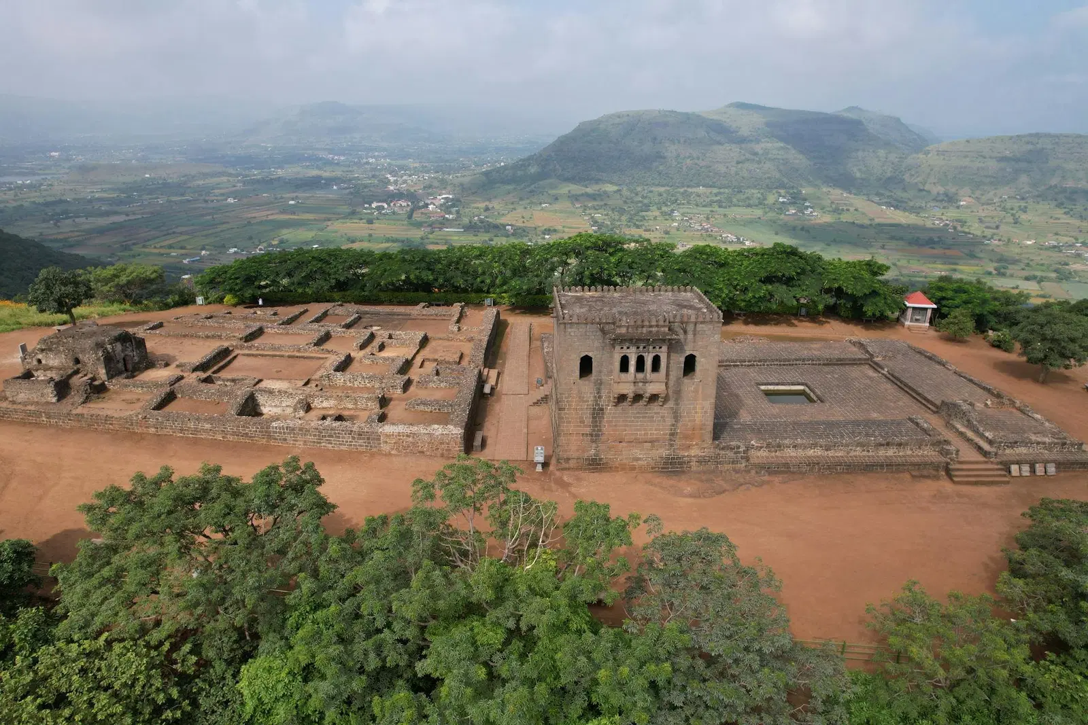

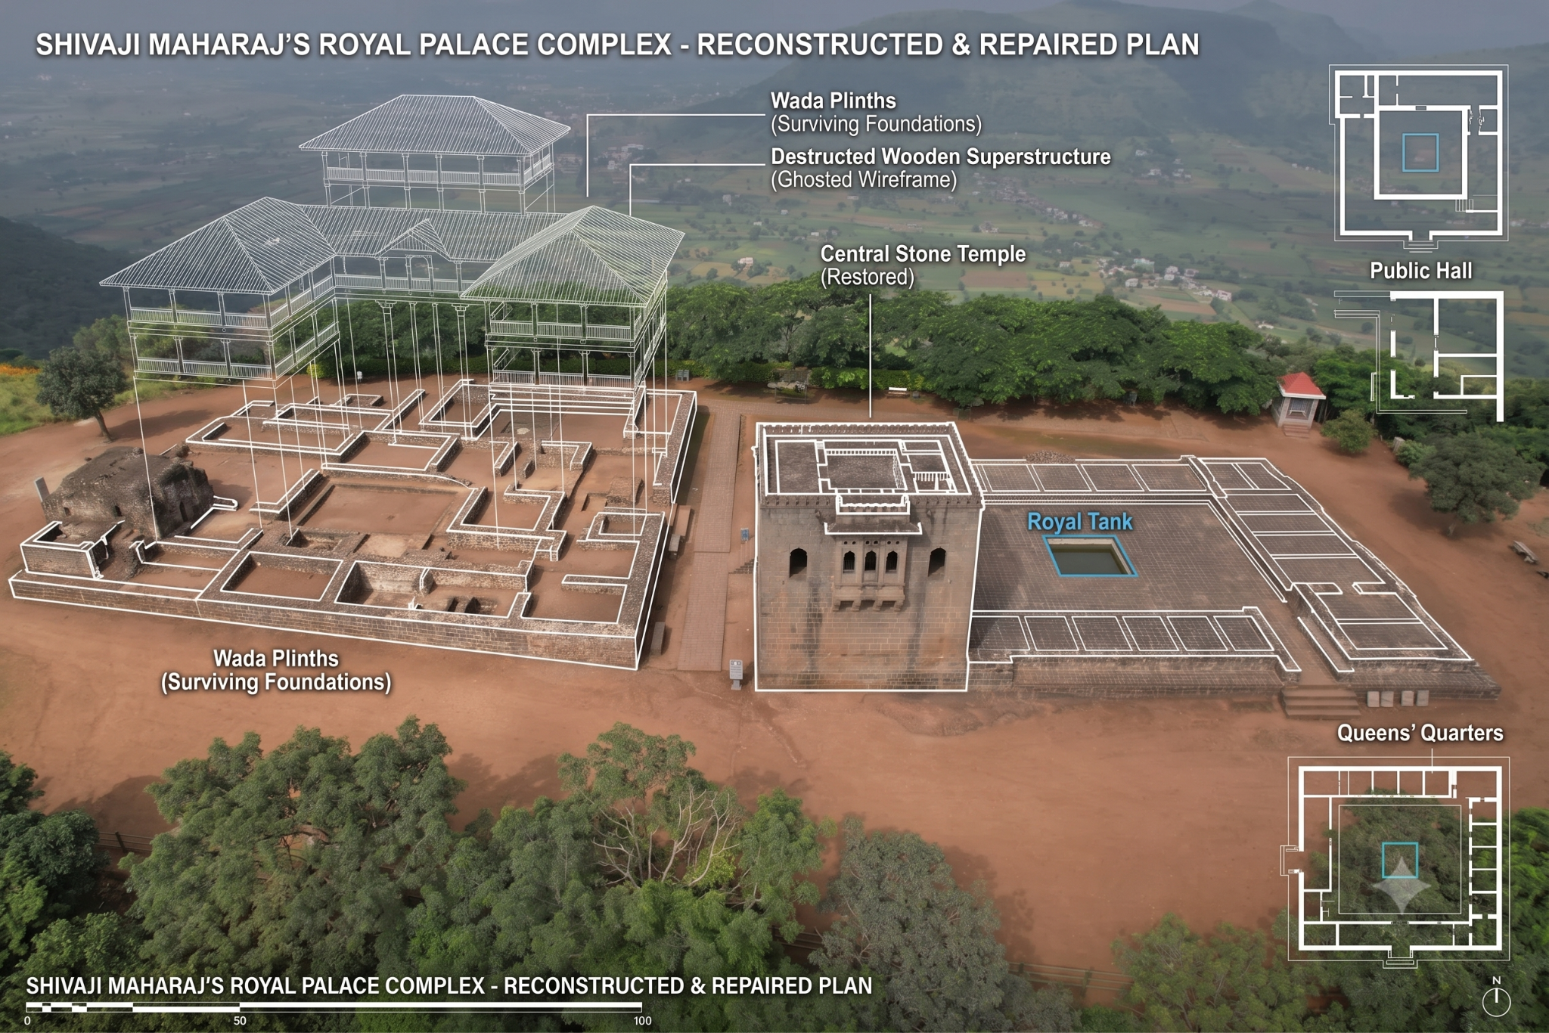

2.⁠ ⁠Rajsadar / Hall of Public Audience

The Rajsadar, where important royal and administrative activities were conducted, survives mainly as ruins. The Government of India identifies the Hall of Public Audience as one of the structures in a bad state of preservation.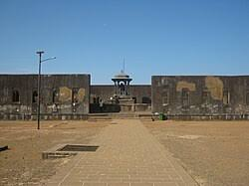

3.⁠ ⁠Royal Complex

The wider Royal Complex has also suffered extensive deterioration. The surviving remains represent only part of the original royal settlement. Government archaeological work has been necessary to identify and conserve these remains.
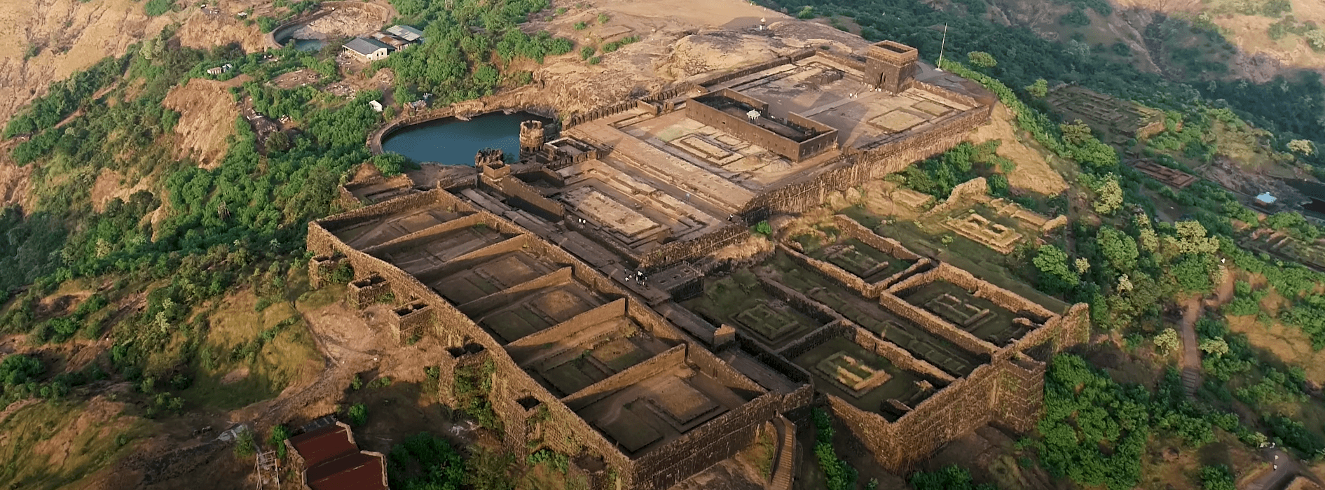

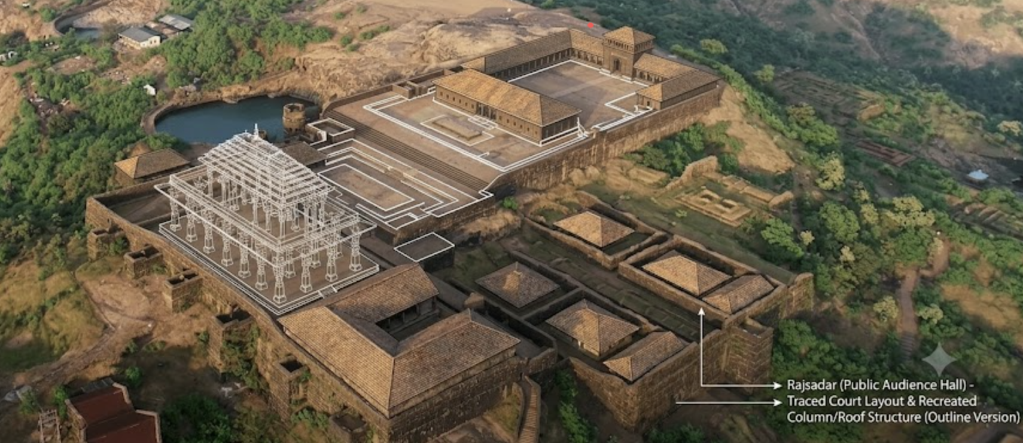

4.⁠ ⁠Ranivasa / Queen's Palace

The Ranivasa (Queen's Palace) is another major surviving ruin. The original residential complex has not survived intact, and only portions of the original construction remain. It is specifically listed by the Government of India among the structures in poor preservation condition.
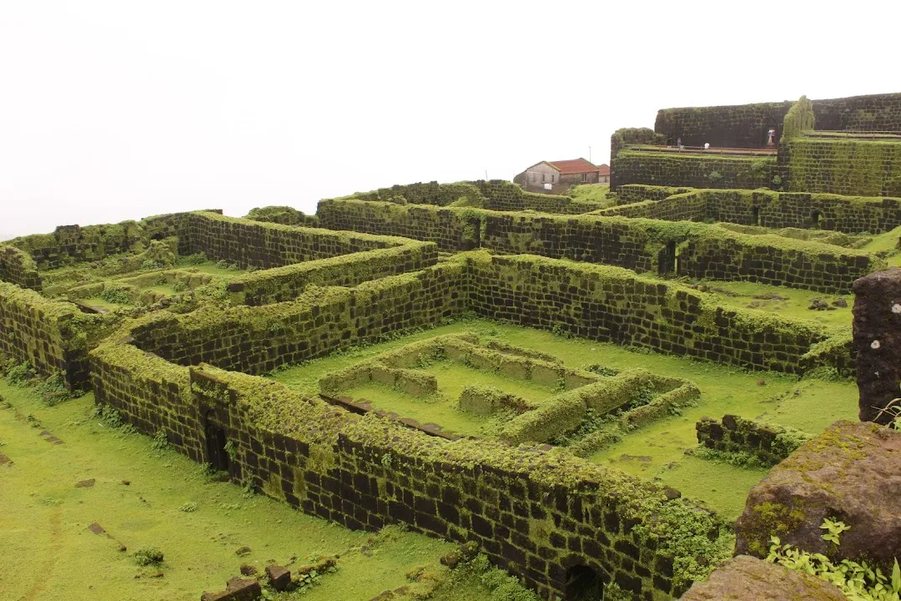
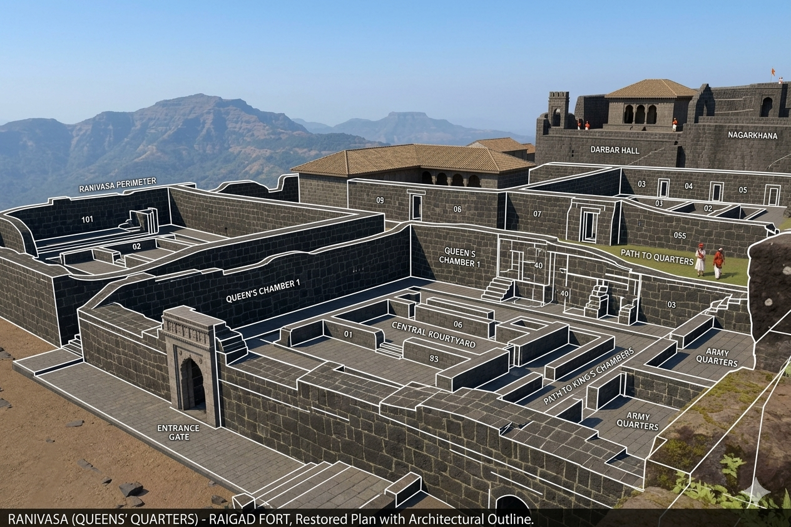
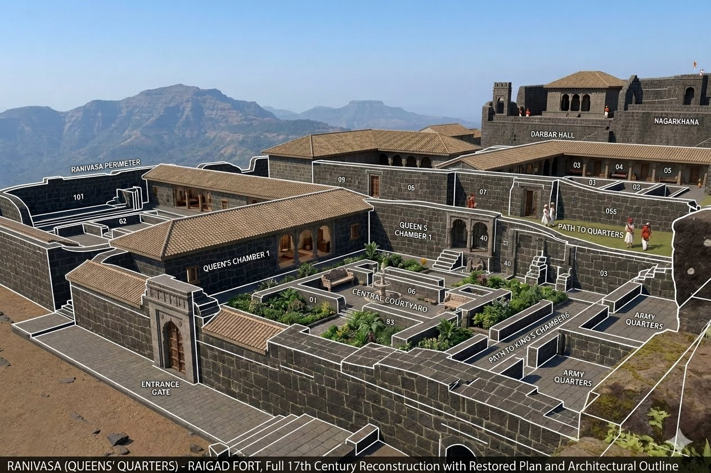

5.⁠ ⁠Bazarpeth / Marketplace

The historic Bazarpeth (marketplace) is now represented mainly by ruins and foundations. The original market was an important part of the functioning capital, but its complete structures no longer survive. The Government of Raigad itself identifies the “ruins of marketplace” as a feature of the fort.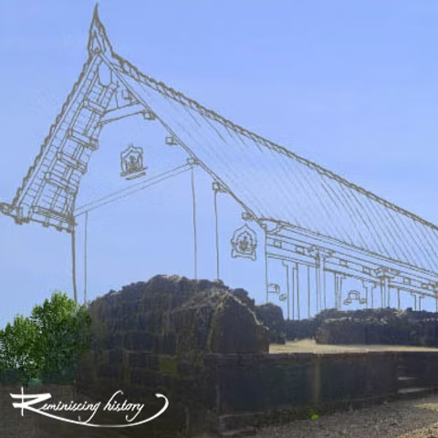

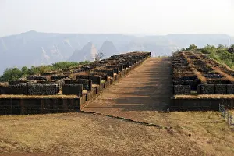

6.⁠ ⁠Manore / Pleasure Pavilions

The Manore, or pleasure pavilions, are listed by the Government of India among the structures that are in poor condition. Their remains provide evidence of the non-military and residential aspects of the former capital.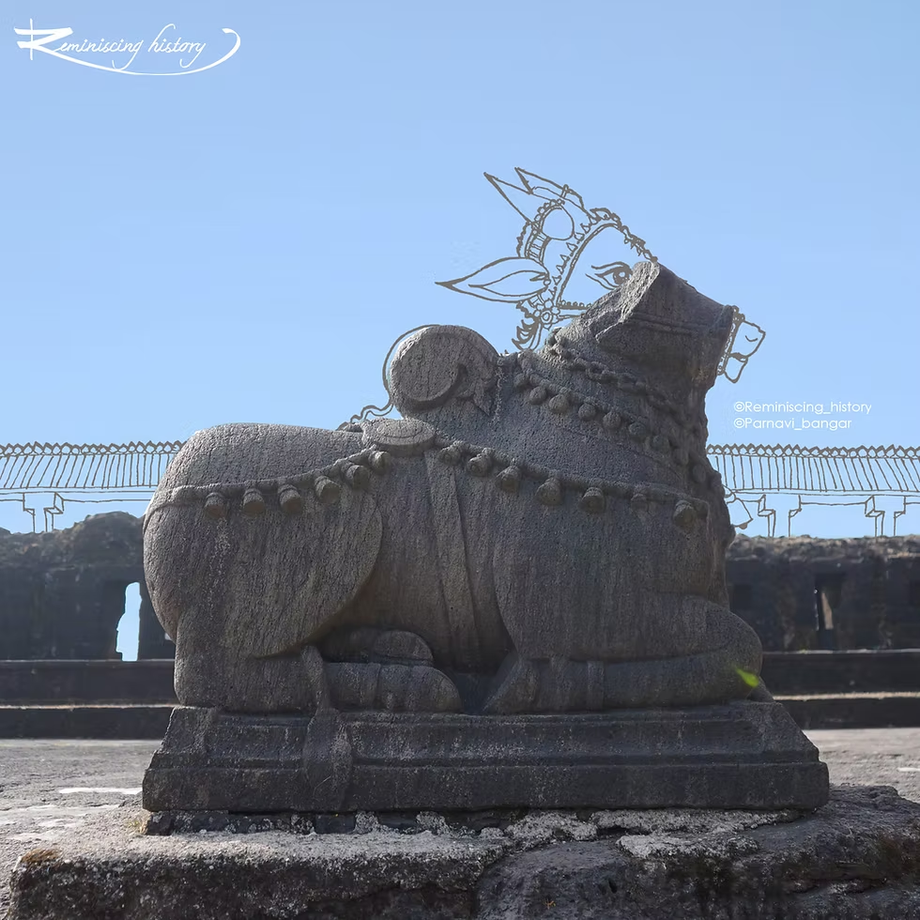
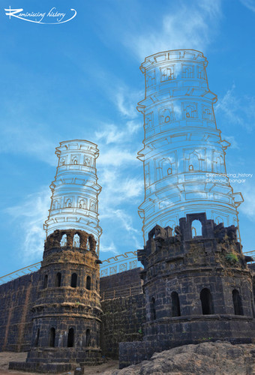

7.⁠ ⁠Wadeshwar Temple

The Wadeshwar Temple is another structure specifically mentioned by the Government of India as being in a bad state of preservation. Unlike the better-preserved Jagadishwar Temple, Wadeshwar survives mainly through its archaeological remains.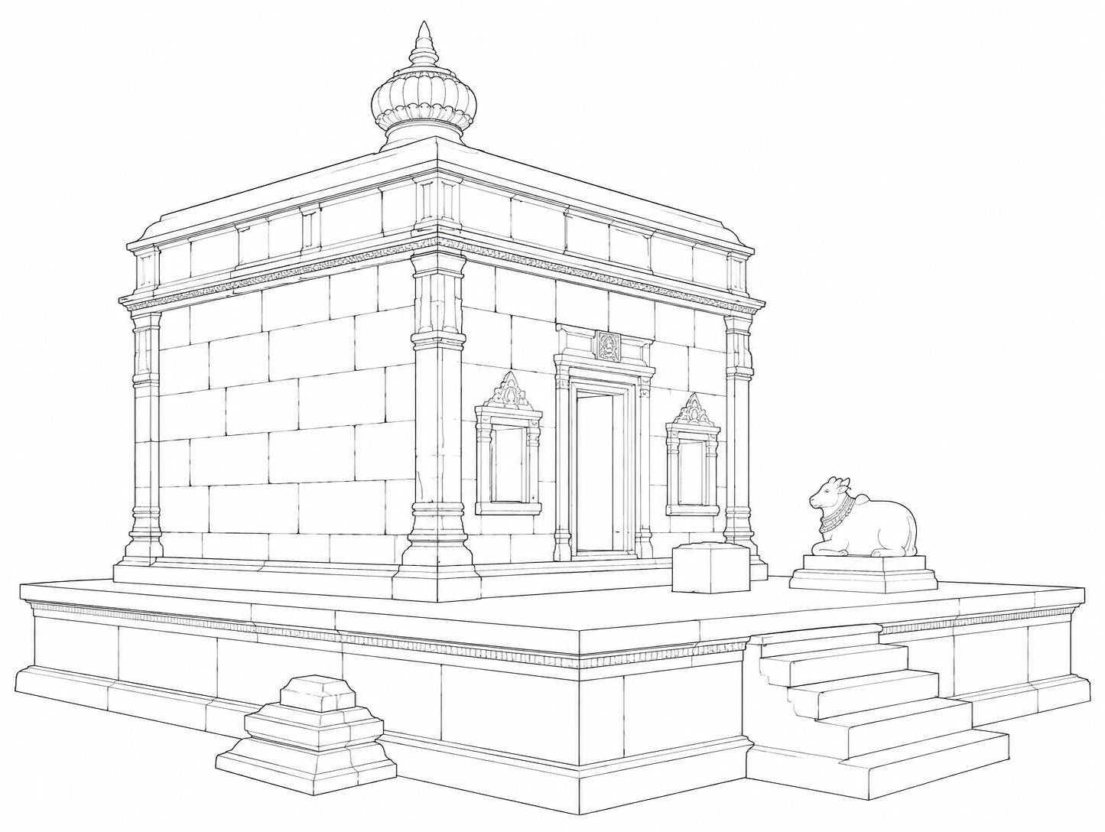
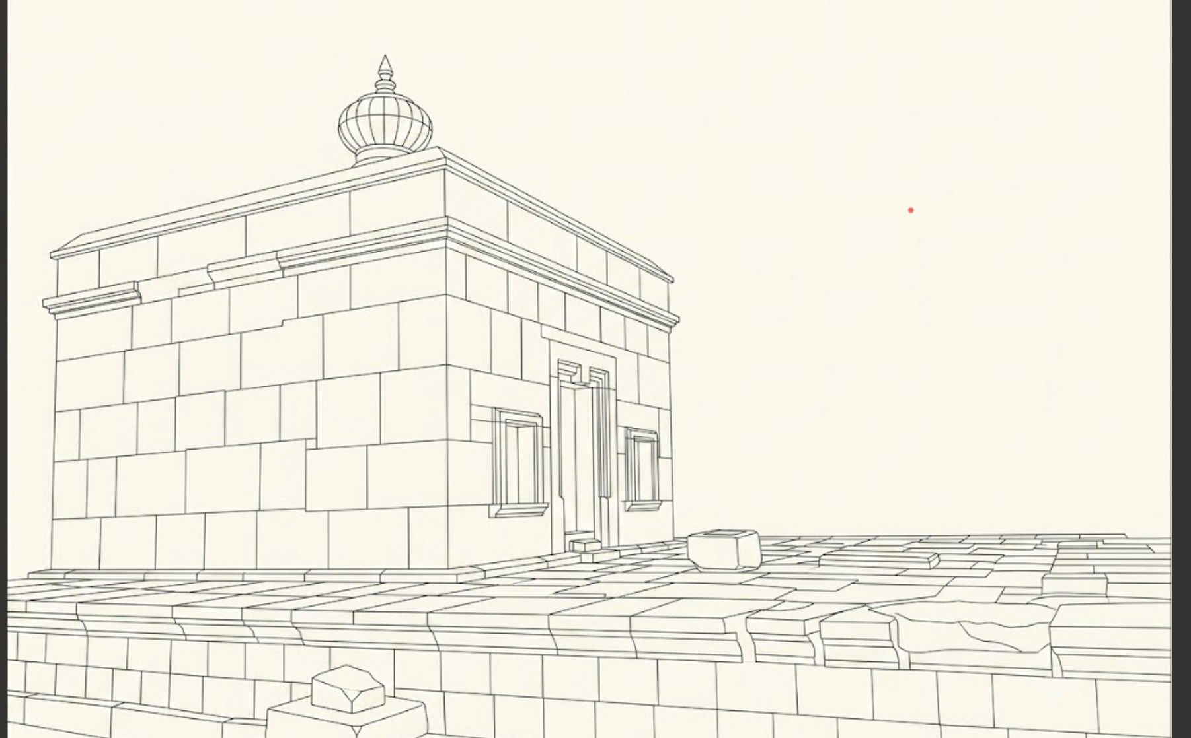
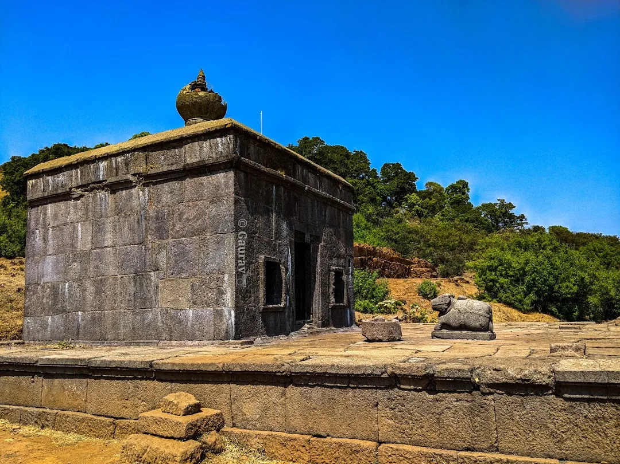

8.⁠ ⁠Khublada Burj

Khublada Burj was an important defensive tower. Government archaeological information identifies it as a strategically located tower from which approaching people could observed. It is among the fort's surviving but deteriorated defensive remains.

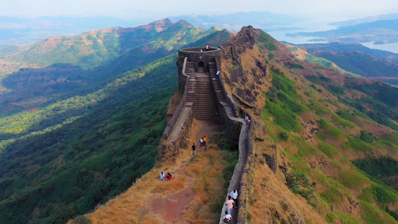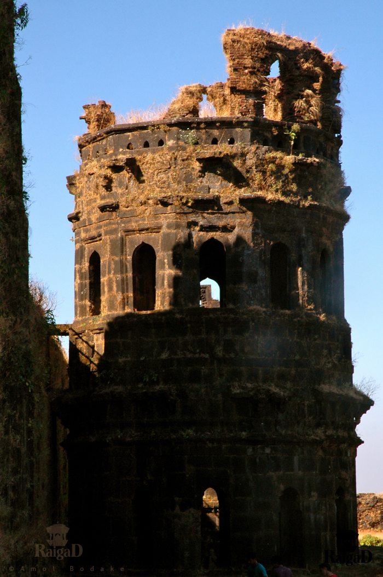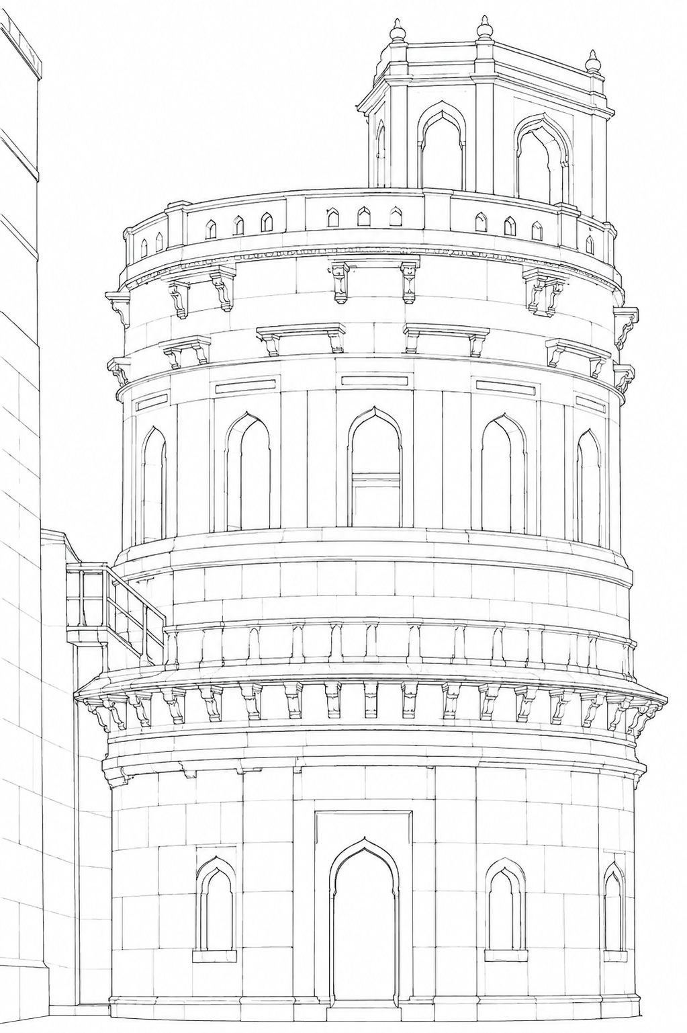

09.⁠ ⁠Nanne Darwaza

The Nanne Darwaza is specifically named by the Government of India as being in a bad state of preservation. It is therefore another example of a fort structure that has not survived in its original condition.


